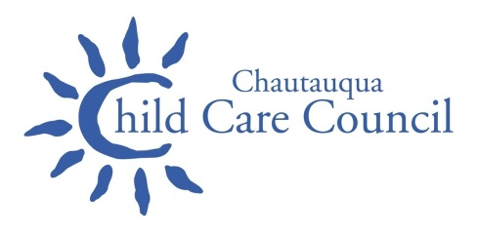

**CHILD CARE CHAT**

**Summer 2020**

  

*Chautauqua Opportunities, Inc.*

*Helping people; Changing lives*

"***I alone cannot change the world, but I can cast a stone across the water to create many ripples."*** -Mother Teresa

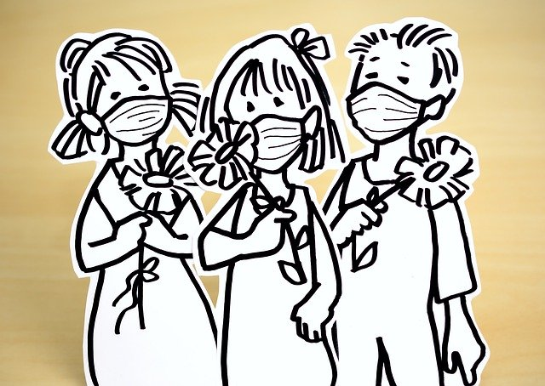

**Chautauqua Child Care Council 402 Chandler St. Jamestown NY 14701**

**1-800-424-4532**

 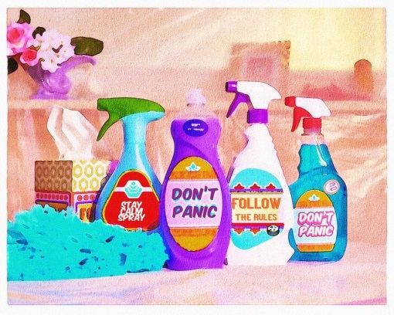

**Child Care and COVID-19**

As New York State begins to open and your families return, it is important to remember the compliance and safety of your program. Emergency regulations that were set in place by the Office of Children and Family Services state, *“Each (enter your modality) day care must operate in compliance with all emergency health guidance promulgated by the Department of Health in the interest of public health during a designated public health emergency. Provided that, during a designated public health emergency, any relevant emergency directives from the executive chamber or from the Department of Health shall supersede regulations of the Office in the case of any conflict.”* In accordance to the emergency regulations we are providing the following documents that explain the interim guidance set forth by OCFS.

*This Interim Guidance for Child Care and Day Camp Programs during the COVID-19 Public Health Emergency (“Interim COVID-19 Guidance for Child Care and Day Camp Programs”) was created to provide owners/operators of child care and day camp programs and their employees, parents/guardians and visitors with precautions to help protect against the spread of COVID-19.*

*This guidance applies only to day child care and camp programs. It does not include overnight child care and camp programs, which are not authorized to operate at this time.*

* **Department of Health Interim Guidance -**<https://www.governor.ny.gov/sites/governor.ny.gov/files/atoms/files/Child_Care_Daycamps_Detailed_Guidelines.pdf>
* **Reopening New York State : Child Care and Day Camp Program Guidelines -** <https://ocfs.ny.gov/main/news/2020/COVID-2020Jun08-Day-Camp-Summary.pdf>

The term “**must**” in the document means this is **required**

The terms “**should**” or “**may**” means it is recommended as a **best practice.**

**Some** of the “musts” include **BUT ARE NOT LIMITED TO**:

* Rooms/spaces must have groups of 15 or fewer children (staff not counted in this number)
* Face coverings must be worn by all staff
* Groups of 15 children and staff should be static- the same groups should stay together as much as possible.
* Post signs-see list on bottom of page 4 of guidance document
* Pool use and sporting activity musts-see page 5 of guidance document
* Serve individual meal portions and practice social distancing for eating
* Discourage field trips and activities away from site
* Prohibit non-essential visitors as much as possible
* Keep logs of Covid-19 screenings (done in-person or remotely) and cleaning/disinfecting
* Contact the local Department of Health and State Department of Health if anyone in the program shows symptoms of Covid-19

Local DOH Covid-19 hotline: 866-604-6789

NYS DOH Covid-19 hotline: [**1-888-364-3065**](tel:18883643065)

* Post completed safety plan on site for employees

**THESE ARE ONLY SOME OF THE REQUIREMENTS. PLEASE READ THE FULL DOCUMENT TO BE IN COMPLIANCE**:

https://www.governor.ny.gov/sites/governor.ny.gov/files/atoms/files/Child_Care_Daycamps_Detailed_Guidelines.pdf or

visit ocfs.ny.gov>Child Care>Updates and Important Announcements, if the link doesn’t work for you.

**Signs and other resources:**

**Attention all staff and visitors poster****Protect yourself poster**

**Face mask poster**

**Cleaning and Sanitizing Guidance:**

<https://coronavirus.health.ny.gov/system/files/documents/2020/03/cleaning_guidance_general_building.pdf>

<http://www.dec.ny.gov/docs/materials_minerals_pdf/covid19.pdf>

<https://www.cdc.gov/coronavirus/2019-ncov/community/disinfecting-building-facility.html?CDC_AA_refV>

<https://www.epa.gov/pesticide-registration/list-n-disinfectants-use-against-sars-cov-2-covid-19>

<https://www.epa.gov/sites/production/files/2020-04/documents/disinfectants-onepager.pdf>

**How to talk with children about the Coronavirus**

**Helping children cope: Webinar**

*The COVID-19 pandemic has caused increased stress and anxiety among many child care providers, families and children. In this webinar, you will learn about the five essential needs of children during disasters (including public health emergencies) and gain practical tips to help children cope through play and self-expression activities.*

<https://info.childcareaware.org/webinar-practical-ways-to-help-children-in-child-care-cope-with-the-covid-19-crisis-a-perspective-from-child-life-specialists>

**Answering Your Young Child’s Questions About Coronavirus**

<https://www.zerotothree.org/resources/3265-answering-your-young-child-s-questions-about-coronavirus>

**Tips for Families: Coronavirus**

The resources in this following link offer tips for families including age-appropriate responses to common questions, a guide to self-care, and activities for young children experiencing social distancing.

1. [Talking about the Coronavirus](https://www.zerotothree.org/resources/3210-tips-for-families-coronavirus#chapter-2436)
2. [Self-Care & Time at Home](https://www.zerotothree.org/resources/3210-tips-for-families-coronavirus#chapter-2437)
3. [Staying Connected](https://www.zerotothree.org/resources/3210-tips-for-families-coronavirus#chapter-2443)
4. [Sesame Street Resources](https://www.zerotothree.org/resources/3210-tips-for-families-coronavirus#chapter-2444)

<https://www.zerotothree.org/resources/3210-tips-for-families-coronavirus>

**Video: “Why Can’t I go to School?”**

<https://www.facebook.com/plugins/video.php?href=https%3A%2F%2Fwww.facebook.com%2FReachdane.org%2Fvideos%2F931918813931573%2F> source credit <http://www.umcard.org/home/>

**Why do we need to wear masks?**

How to answer your child’s questions about why people are wearing masks and covering their faces: <https://www.zerotothree.org/resources/3211-why-are-people-wearing-masks-why-are-people-covering-their-faces>

**The value of using books and storytelling to teach about Coronavirus**

**The Power of Storytelling in Early Childhood: Helping Children Process the Coronavirus Crisis** <https://www.naeyc.org/resources/blog/power-storytelling-helping-children-process-crisis>

**Free Downloadable Books for children**

**Fighting the Big Virus: Trinka, Sam, and Littletown Work Together** <https://piploproductions.com/trinka-and-sam-virus/>

**Something Strange Happened in my City** <https://fdafdaa5-78a3-4b52-a60c-bbc1ed5e8667.filesusr.com/ugd/d4e6d3_e6d1e88990374bd59c9de2b3b273e47f.pdf>

**I Can Be Safe and Healthy by Washing My Hands!** <https://challengingbehavior.cbcs.usf.edu/docs/washing-hands_story.pdf>

**Why we stay home, Suzie learns about Carona Virus** <https://www.millieandsuzie.com/>

Videos of this book being read aloud: [**https://www.youtube.com/results?search_query=%23whywestayhomesuzielearnsaboutcoronavirus**](https://www.youtube.com/results?search_query=%23whywestayhomesuzielearnsaboutcoronavirus)



**The importance of washing hands**

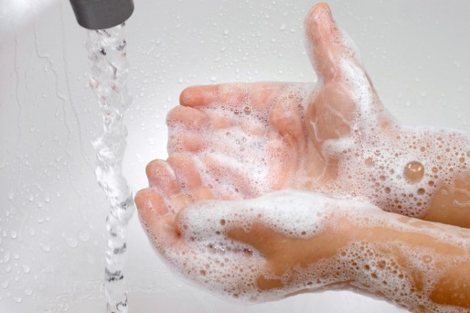

You can do the pepper/water/soap experiment with your children to illustrate the importance of using soap when washing hands. The most important thing is to wash your hands using soap and water for at least 20 seconds, about the time it takes to sing “Happy Birthday” twice. Here’s a link describing this activity: <https://behrend.psu.edu/files/pdf/49646/2020/04/08/bd-science-home-pepper-soap.pdf>

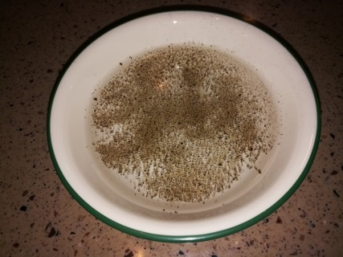 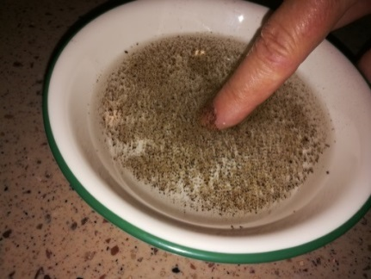 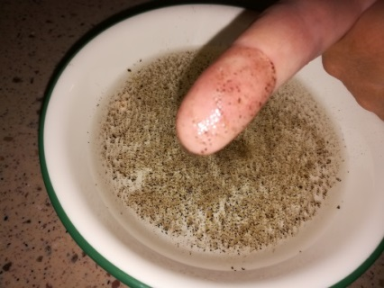

**Figure 1 Pepper (“germs”), Figure 2 Dip finger into water Figure 3 Pepper (“germs”) stick to finger   
 floating on water**

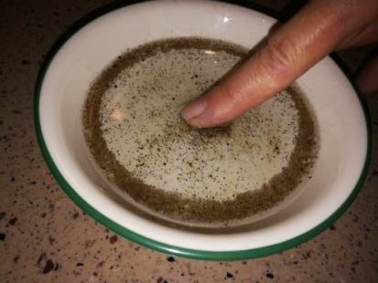 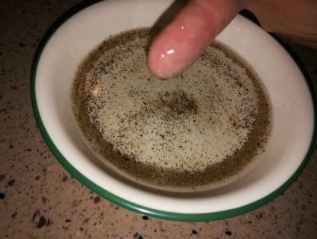

**Figure 4 Put dish soap on finger, Figure 5 Pepper (“germs”) move away,   
dip finger in water don’t stick to finger**

**The importance of washing hands (continued)**

**Sticker templates you can download to print for children washing their hands**

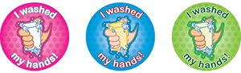

<https://www.cdc.gov/handwashing/pdf/handwashing-stickers-avery-template-u-0099-01_p.doc>

**Sesame Street videos and activities about washing hands and staying healthy:**

<https://sesamestreetincommunities.org/topics/health/>

<https://www.youtube.com/watch?v=ojI46TakX3A&feature=emb_rel_end>

<https://youtu.be/mxck67CTQ18>

<https://www.youtube.com/watch?v=yQn0z6xa8II>

**Other video about washing hands:**

<https://www.youtube.com/watch?v=dDHJW4r3elE>

**Other handwashing resources:**

<https://www.cdc.gov/handwashing/images/campaign2018/GHD-UVLight-1080x1080.gif>

<https://www.cdc.gov/handwashing/images/campaign2018/handwashing-uv-light-1080px.jpg>

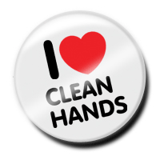

**Help Stop the Spread of   
COVID-19 in Children**



Tips to Protect Children During a COVID-19 Outbreak <https://www.cdc.gov/coronavirus/2019-ncov/daily-life-coping/children/protect-children.html>

**Information for Breastfeeding women**

<https://www.cdc.gov/coronavirus/2019-ncov/hcp/care-for-breastfeeding-women.html>

<https://www.cdc.gov/coronavirus/2019-ncov/need-extra-precautions/pregnancy-breastfeeding.html>

**Household planning and checklist**

How you can plan and prepare during this COVID-19 pandemic to help protect your family.

<https://www.cdc.gov/coronavirus/2019-ncov/daily-life-coping/checklist-household-ready.html>

**Information and Resources from NAEYC (The National Association for the Education of Young Children) to use during this COVID-19 Pandemic**

<https://www.naeyc.org/resources/topics/covid-19>

**Solve the Outbreak Game:** <https://www.cdc.gov/mobile/applications/sto/web-app.html>

**CACFP NEWS**

**Some Exciting Changes to the “Crediting Foods in CACFP” Handbook!**

**These changes will be included in a revised handbook,**

**but, for now, please refer to this Attachment A.**

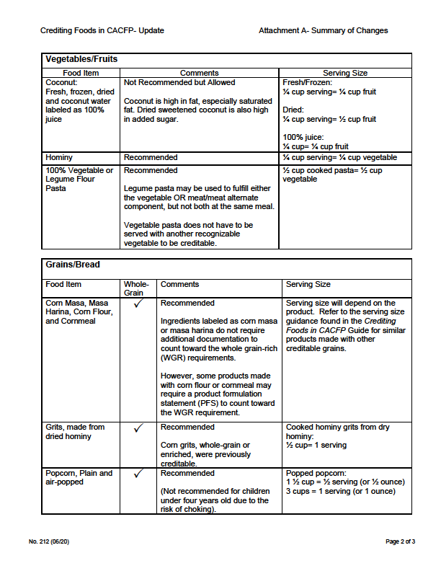

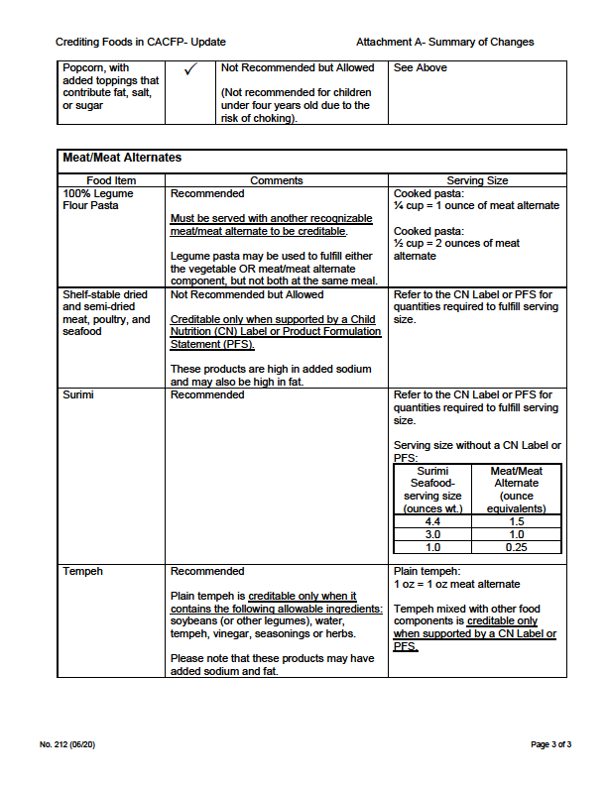

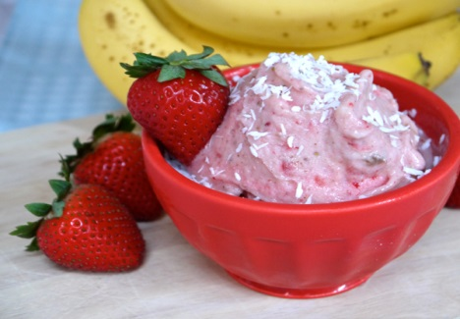

Healthy Snack #5: Frozen Fruit

Cups

Use this link to learn how to prepare this delicious and healthy frozen snack. Watch the video with the children and let them help with preparing this treat.

<https://www.youtube.com/watch?v=2Y9mPmbiwy8&feature=youtu.be>

 For more healthy recipes, go to:

<https://www.choosemyplate.gov/browse-by-audience/view-all-audiences/children/kids/videos-songs>

**Make Infused Water to Help Children**

**Drink More!**

25 EPIC Infused Waters + FREE eBook! - Mind Over Munch

 Use this link to help kids drink more water. Hint: to prevent issues that could cause choking, strain the water and serve without the fruit and seeds or puree the fruits for a no-sugar-added beverage. Let the children select the fruits or herbs to add to the water when they arrive for the day, refrigerate and serve. Allow each child to create his or her own beverage.

<https://www.youtube.com/watch?v=AVlm7ShSvxc>

**2020 Training is Due! Only 1 Hour Per Year + Civil Rights**

Coming soon will be Nutrition Bingo and Jeopardy—watch for information. You can always “attend” training online at: <https://www.cacfp.org/resources/learning-center/thirty-thursdays/>. You can watch webinars live or webinars that have been recorded. Go to chautauquaopportunities.com for the civil rights training. Let the CACFP Specialist know if you have any questions.

**CACFP Training is required!**

Failure to obtain 1 hour of training plus civil rights is a serious deficiency!

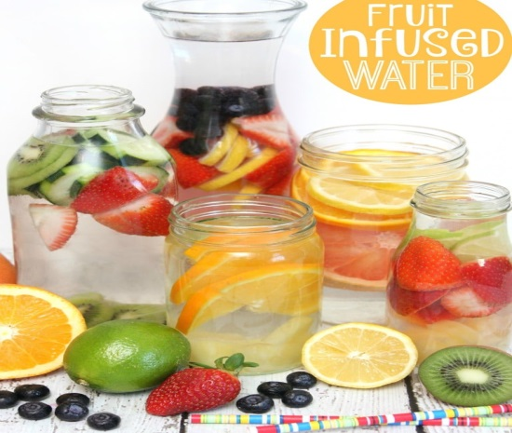

ADVOCACY AT WORK!!! 

NYS Assemblyman Andy Goodell and U.S. Congressman Tom Reed visit local day care center to discuss child care issues!

See the article at:

<https://www.post-journal.com/news/local-news/2020/06/reed-goodell-discuss-local-child-care-issues/>   
  
  
  
 Keep It Going!!!

**Your Government Representatives**

Governor Andrew Cuomo-<https://www.governor.ny.gov/>

State Senator George Borrello-Phone: [borrello@nysenate.gov](mailto:borrello@nysenate.gov) or 716-664-4603/518-455-3563

State Assemblyman Andrew Goodell-[goodella@nyassembly.gov](mailto:goodella@nyassembly.gov) or 716-664-7773/518-455-4511

U.S. Congressman Tom Reed-<http://www.reed.house.gov> or (716) 708-6369/ (202) 225-3161

U.S. Senator for New York Chuck Schumer- [www.schumer.senate.gov](http://www.schumer.senate.gov) or (716)846-4111/ (202)224-6542

U.S. Senator Kirsten Gillibrand- [www.gillibrand.senate.gov](http://www.gillibrand.senate.gov) or (716) 854-9725 or (202) 224-4451

Chautauqua County Executive- [wendelp@co.chautauqua.ny.us](mailto:wendelp@co.chautauqua.ny.us) or

North County Toll Free: 716-363-4211

South County Toll Free: 716-661-7211

City of Dunkirk- <http://www.dunkirktoday.com/>

City of Jamestown- <http://www.jamestownny.net/>

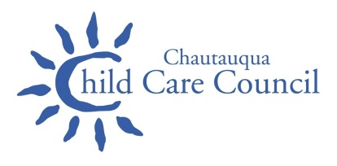

# Chautauqua Child Care Council Advisory Board Members

Dr. Jennifer Berke

Dr. Mira Berkley

Bonnie Caldwell

Jessie Hill

Jill Triana

Judy Yarber

Lindsey Ellis

Stephanie Stevens

Marilyn Orlando

Donna Shepard

Sharon Rinehart

Denise Smith

Elizabeth Starks

Patricia Harper

Angela Moran

**If You Are Interested In Becoming A Council Advisory Board Member, Please Contact the Child Care Council:**

**716-661-9430 Ext. 2227**

*Giving Providers, Parents and Businesses*

*the Resources to Better Our Children’s Future*

**Chautauqua Child Care Council**

Staff Director:

Susan Marker ...........(716) 661-9430 ext. 2227

Child Development Specialist:

Beth Faulkner............(716) 661-9430 ext. 2295

Child Development Specialist:

Megan Saeli.............(716) 661-9430 ext. 2260

Child Development Specialist:

Lorrie Dean............(716) 661-9430 ext. 2273

Child Development Specialist:

Alisha Perry..............(716) 661-9430 –ext2293

Legally Exempt Program Specialist:

Heidi Woodard.........(716) 661-9430 ext. 2300

Resource and Referral Specialist:

Erika Hines ............ (716) 661-9430 ext. 2261

Registrar:

Chirvhoua Churjeng.....(716) 661-9430 ext. 2289

Registrar:

Patti Dudenhoeffer.........(716) 661-9430 ext. 2290

CACFP Program Specialist:

Chris Wigren..............(716) 661-9430 ext. 2269