 COI, Inc. Helping People; Changing Lives 1-800-424-4532

*Giving Providers, Parents and Businesses*

*the Resources to Better Our Children’s Future*

*[Type a quote from the document or the summary of an interesting point. You can position the text box anywhere in the document. Use the Drawing Tools tab to change the formatting of the pull quote text box.]*

*[Type a quote from the document or the summary of an interesting point. You can position the text box anywhere in the document. Use the Drawing Tools tab to change the formatting of the pull quote text box.]*

**CHAT**

October-December 2020

* **News!**
* Our website will have a new look and be more user friendly!
* A new database system will be launched for child care referrals! This system will allow providers and referral counselors to interact more easily to track slot vacancies and other information!
* Our new Support Service Specialist, Jen Graham, came on board in July and has been a great help to us all!
* Referral Specialist, Erika Hines, moved on to a new career opportunity. We appreciate all she did while here, and we will miss her greatly!
* Lorrie Dean, Child Development Specialist, has retired. We will miss her, and wish her the best!
* Megan Saeli, Child Development Specialist, will be leaving for a while to take care of her newest family member due this autumn! Best wishes to her and her family!

This quick and easy recipe might get the children to eat squash along with the delicious baked apples. Let them help clean out the seeds in the squash, mix the ingredients, and stuff the squash. The more fun they have in helping to prepare a meal, the more likely they are to try new foods!

All you need is a microwave to cook this delicious and seasonal\* side dish.

**Apple-Stuffed Squash**

Ingredients

4 acorn squash (washed)

1 tablespoon butter (or margarine)

2 apples (chopped)

2 teaspoons brown sugar (2 Tablespoons, packed)

1/2 teaspoon cinnamon

Directions

1. Cut squash into halves and remove seeds. Place in a glass dish, cover with plastic wrap and microwave on high for 5 minutes.

2. Melt butter in a separate bowl in the microwave. Mix in apples, sugar, and cinnamon. Microwave for 1½ minutes.

3. Spoon apple filling into each squash half. Cover and microwave on high for 3-5 minutes until squash and apples are tender. Serve warm.

Source: University of Maryland Extension Food Supplement Nutrition Education Program.

<https://www.choosemyplate.gov/recipes/supplemental-nutrition-assistance-program-snap/apple-stuffed-squash>

**\*Why eat what is in season? The food is often fresher, you may find more varieties, you will have more locally grown options which helps the local economy, in-season fruits and vegetables are usually less costly.**



**2020 is winding down - be sure you have at least 1 hour of CACFP-approved training plus civil rights!**

**You can find training online at:**

<https://www.cacfp.org/resources/learning-center/>

<https://www.fns.usda.gov/tn/halftime-cacfp-thirty-thursdays-training-webinar-series>

**Civil rights training:** [**http://www.cn.nysed.gov/civilrights**](http://www.cn.nysed.gov/civilrights)



|  |  |
| --- | --- |
| Inside This Issue | |
| 2 | CACFP-Recipe |
| 3 | Parents and Providers-Fun Activity |
| 4 | Providers-Roles in Remote Learning |
| 5-6 | Family Community Events |
| 7 | Training |
| 8 | Helpful Links |

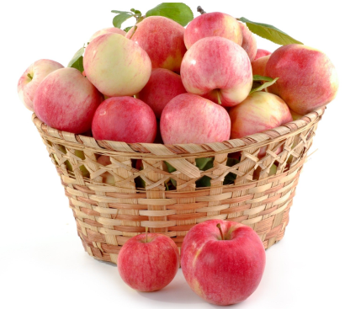



****

**Fall is a great time of year to engage with children in nature! From the changing color of the fall leaves to falling pinecones, children will love to see how nature changes with the seasons. A great way to enjoy nature is to take the fallen pinecones and turn them into birdfeeders for the birds at your home!**

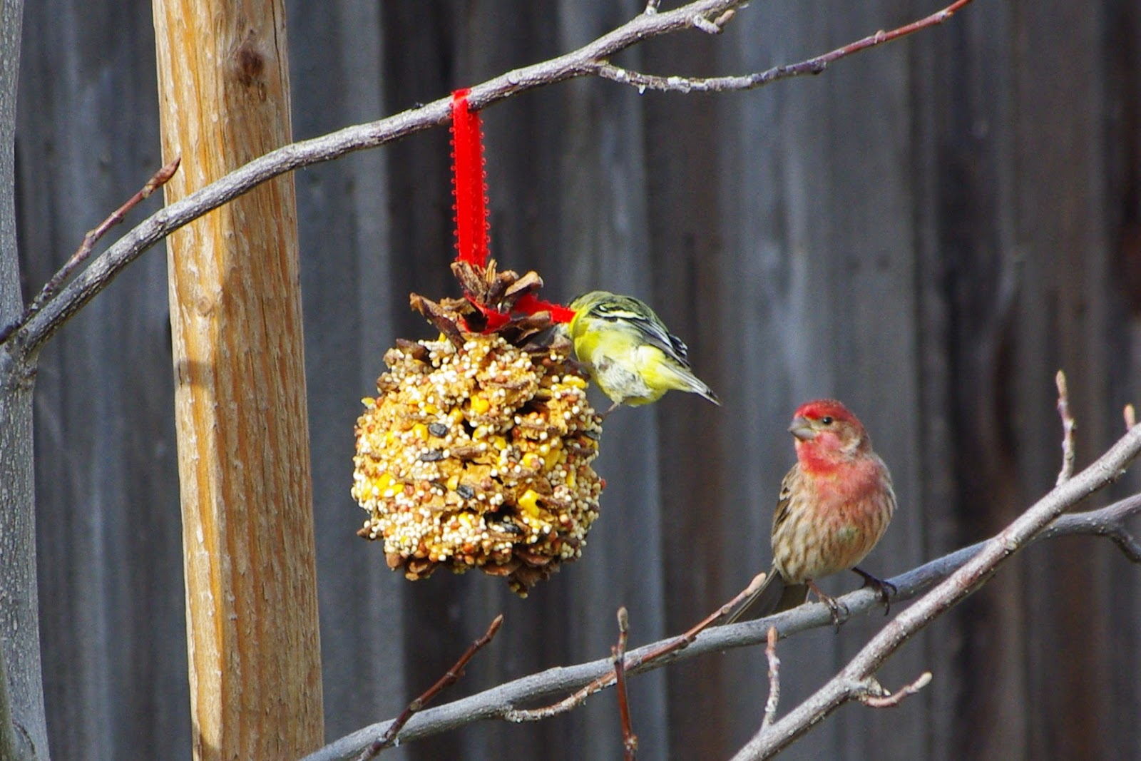

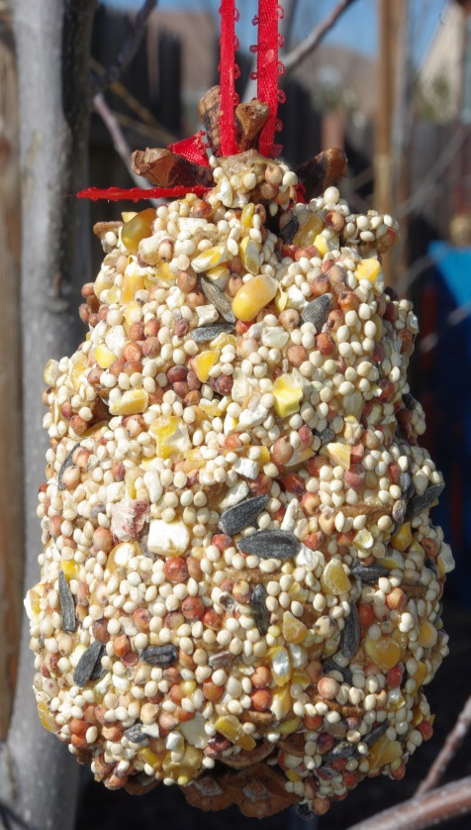

To create a pinecone birdfeeder you will need to follow the below steps:

1. Collect pinecones
2. Fill the bottom of a shallow pan with birdseed
3. Cover the pinecones in peanut butter
4. Once the pinecone is covered in peanut butter place it in the tray with the birdseed.
5. Roll the pinecone around in the birdseed until it is completely covered.
6. Tie a ribbon around the top of the pinecone
7. Hang it from your favorite tree!
8. Watch the birds enjoy!



**Roles and Responsibilities of Remote Learning in Child Care**

This fall is a new school year and does look different than the years prior as we enter our seventh month of the COVID-19 emergency this September. Following social distancing guidelines and practices, and now with added remote learning and virtual learning or hybrid model learning, Child Care Providers are being called upon to serve children and families during these times.

New OCFS emergency regulations did come out on August 19, 2020, to clarify that school age children may attend child care programs during the academic year when children are not physically present in school during the regular school days.

As Child Care Providers, you have to consider accommodations to your program when taking in school age children with remote learning. OCFS does encourage programs to develop agreements with their families with regards to remote learning roles and responsibilities. The primary role of a Child Care Provider is to care and supervise children in the Provider’s Program following regulations of OCFS. Therefore, children participating in remote learning cannot be isolated and must be supervised per regulation. As a reminder, Child Care Providers are not classroom teachers or tutors and are not expected to serve in that capacity.

Remote learning is an educational learning objective, thus electronic devices for purposes of visual media are allowed. Remote learning that causes a distraction to the Provider where it affects the quality of care is not allowed. As a Child Care Provider, you have discretion whether to support remote learning in your programs or not.

Just remember that parents are responsible for providing materials needed for their child to participate in remote learning that includes assignments, books, and laptop or tablet. A schedule of the child’s remote learning with what time they’re expected to log in should be discussed and provided to the Provider. Any academic concerns regarding the child are addressed to the school teacher and not the Child Care Provider. Again, the care and supervision of children remains the Primary role of the Child Care Provider.

Please call your Regulators with any questions.

Please refer to the Office of Children and Family Services for any new updates in regards to Child Care under Updates and Important Announcements and the Dear Provider Letters of OCFS.

<https://ocfs.ny.gov/programs/childcare/>

<https://ocfs.ny.gov/programs/childcare/regulations/>

[**Register Today**](https://go.zerotothree.org/e/565212/mail-utm-campaign-vpdebate2020/22vr7v/555078281?h=0zbqlZODXU0OJ_U0BF89WZFoLbB_W4cmeAnOw5Fo0ho)



**October 7**-a two-part *Think Babies* *Vice-Presidential Debate Watch Party*.

The live, virtual event will begin with a dynamic panel discussion before the Vice-Presidential debate at 8:00 pm ET. Then, join us for a Tweet Chat with Every Child Matters at 9:00 pm ET to live tweet the debate.

UPCOMING FAMILY EVENTS!

**OCT**

**09**

[Audubon Enchanted Forest](https://www.tourchautauqua.com/events/audubon-enchanted-forest)

Jamestown

Walk the Nature Center’s luminary lit trails and meet talking animals who share stories about their lives. This is a wonderful non-scary Halloween event for children and their adults. Talking animals will engage your imagination, maybe make you laugh and teach you something about the wildlife in the region. Stay for crafts and snacks as you explore the Nature Center after your walk. For an additional $3, you can also earn a Fun Patch.

 716.569.2345

[auduboncnc.org](https://auduboncnc.org/)

**NOV**

**21**

[Fenton History Center Annual Holiday Exhibit](https://www.tourchautauqua.com/events/fenton-history-center-annual-holiday-exhibit)

Jamestown

November 21- January 4th: Annual Holiday Exhibit "The Enchanted World of The Nutcracker"

 716.664.6256

[fentonhistorycenter.org](https://www.fentonhistorycenter.org/)

**DEC**

**05**

[Annual Miracle on Main Street](https://www.tourchautauqua.com/events/annual-miracle-on-main-street)

Fredonia

Santa comes to town with activities and fun times for kids & the whole family including caroling, the official Village holiday tree lighting in the park with refreshments, shopping and much more. A fun, family festival! Obtain “Passports” from area businesses and get them stamped by the businesses to be entered in a special drawing from the Fredonia Community Chamber of Commerce. Schedule TBA.

[festivalsfredonia.org](https://festivalsfredoniany.org/" \t "_blank)

**Please be sure to contact the event venue regarding the most up-to-date information on their event.**



Need Training Hours?

If you’re a Family or Group Family Day Care Provider and need OCFS training hours, look no further than the Chautauqua Child Care Council. The Professional Development Team is happy to provide FREE trainings for groups of 5 on any OCFS topic!

Call 716-661-9430 to schedule your training today!



*“An investment in knowledge pays the best interest.”*

*-Benjamin Franklin*



**Helpful Links**

<https://luckylittlelearners.com/35-useful-remote-learning-resources/>

* 35 links to help with and/ or enhance remote learning

<https://chqgov.com/board-of-elections/Board-of-Elections>

* Chautauqua County Board of Elections voting information

<https://chqgov.com/public-health/public-health>

* Public Health Information

<https://www.cdc.gov/>

* Centers for Disease Control and Prevention

<https://www.aap.org/en-us/Pages/Default.aspx>

* American Academy of Pediatrics- Medical information and research regarding children’s health

<https://www.who.int/>

* World Health Organization



# Chautauqua Child Care Council Advisory Board Members

Dr. Jennifer Berke

Dr. Mira Berkley

Bonnie Caldwell

Jessie Hill

Jill Triana

Judy Yarber

Lindsey Ellis

Stephanie Stevens

Marilyn Orlando

Donna Shepard

Sharon Rinehart

Denise Smith

Elizabeth Starks

Patricia Harper

Angela Moran

**If You Are Interested In Becoming A Council Advisory Board Member, Please Contact the Child Care Council:**

**716-661-9430 Ext. 2227**

**Chautauqua Child Care Council Staff**

**Director:**

Susan Marker ...........(716) 661-9430 ext. 2227

**CACFP Specialist:**

Chris Wigren..............(716) 661-9430 ext. 2269

**Legally Exempt Program Specialist:**

Heidi Woodard.........(716) 661-9430 ext. 2300

**Child Development Specialist:**

Beth Faulkner............(716) 661-9430 ext. 2295

**Child Development Specialist:**

Megan Saeli.............(716) 661-9430 ext. 2260

**Child Development Specialist:**

Alisha Perry..............(716) 661-9430 –ext.2293

**Registrar:**

Chirvhoua Churjeng.....(716) 661-9430 ext. 2289

**Registrar:**

Patti Dudenhoeffer.........(716) 661-9430 ext. 2290

**Support Service Specialist**

Jennifer Graham……….(716) 661-9430 ext. 2245

Referrals…………………(716) 661-9430

**Mission Statement – Chautauqua Child Care Council**



*The Chautauqua Child Care Council works to foster collaborative relationships in order to build a strong responsive child care support system meeting the needs of all Chautauqua County families, child care providers, businesses and communities.*

**Be In The Know.**

**Take An Active Role In Child Care.**

Early care and education policy needs

your support in order to truly give

all children a great start in life.

For more information go to:

www.naccrra.org/public-policy

or call 716-661-9430

Thank you!

NON-PROFIT ORGANIZATION

U.S. POSTAGE PAID

DUNKIRK, NY 14048

PERMIT #8